古生物、精时地层及化石能源国际研讨会
International Conference on Palaeobiology, High Resolution Stratigraphy and Fossil Energy

November 18-19, 2021, Nanjing China

First Circular

To celebrate the 70th Anniversary of Nanjing Institute of Geology and Palaeontology, Chinese Academy of Sciences (NIGPAS), the International Conference on Palaeobiology, High Resolution Stratigraphy and Fossil Energy will be held in Nanjing during 18-19 November 2021. The Organizing Committee cordially invites you to join us for this big convention. The conference will concentrate on recent advances and perspectives in the fields of palaeobiology, stratigraphy, fossil energy and other relevant areas.

VENUE
Nanjing Museum of Palaeontology, NIGPAS, 39 East Beijing Road, Nanjing, China.

SPONSORS
Nanjing Institute of Geology and Palaeontology, Chinese Academy of Sciences

ORGANISERS
State Key Laboratory of Palaeobiology and Stratigraphy (LPS)
Nanjing Institute of Geology and Palaeontology, Chinese Academy of Sciences (NIGPAS)

STEERING COMMITTEE
Chairs: RONG Jiayu, CHEN Xu, ZHOU Zhiyan
Members (listed in alphabetical order):
DING Lin, GUO Zhengtang, HAO Fang，JIN Zhijun, LI Xianhua, QIU Zhanxiang, SHEN Shuzhong, SHU Degan, WANG Chengshan, WANG Pinxian, WANG Tieguan, WU Fuyuan, WU Xinzhi, YIN Hongfu, XU Yigang, ZHANG Miman, ZHOU Zhonghe, ZOU Caineng

ORGANIZING COMMITTEE
Chair: ZHAN Renbin, Director of NIGPAS
Vice Chair: WANG Jun, Vice-Director of NIGPAS
Members: (to be completed)

SCIENTIFIC COMMITTEE
Chair: ZHU Maoyan, NIGPAS
Vice Chair: WANG Bo, NIGPAS
Members: (to be completed)

SECRETARY
Secretory-General:
WU Rongchang NIGPAS
CHEN Xiaozheng NIGPAS
Members:
WANG Dan NIGPAS
YIN Zongjun NIGPAS
WAN Mingli NIGPAS

PRELIMINARY AGENDA
Nov. 17, 2021 (Wednesday): Arrival and ice breaker
Nov. 18, 2021 (Thursday): Opening ceremony, invited plenary talks and other lectures
Nov. 19, 2021 (Friday): Invited plenary talks and other lectures
Nov. 20, 2021 (Saturday): Departures

INVITATION AND VISA
An official invitation letter will be available for participants upon request for their application for visas at the Embassies or Consulates of China in their own countries. Such invitation letter will be arranged by electronic version (PDF file) signed by the Chair of the Organizing Committee with the official seal and will be sent to participants as email attachments. Those who need an Invitation Letter are supposed to provide following information when making their preliminary registration:
1) Full name (Family and given names);
2) Gender;
3) Date of birth;
4) Nationality;
5) Passport number and valid dates (a scanned file of passport is required);
6) Institution or affiliation;
7) Periods of stay in China.
NOTE: With respect to the VISA to China, please pay attention to the visa policy of the Embassy/Consulate of China in the local area.

TRANSPORTATION
All delegates outside Nanjing are suggested to stay in the Jiuhua Hotel, about 600 m east of NIGPAS along the same side of the East Beijing Road. It is about 44 km to the Nanjing Lukou International Airport, and about 5 km to the Nanjing High Speed Railway Station. Public underground transportation is very convenient between the Hotel and the Airport or Station.

ACCOMODATION AND HOTEL RESERVATION
Jiuhua Hotel: We will book some hotel rooms in advance with a special discount. Delegates who need can contact us when make the registration.

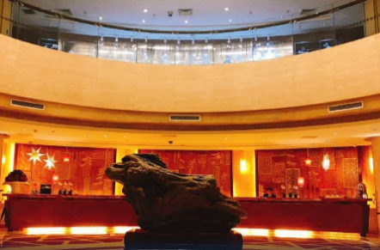
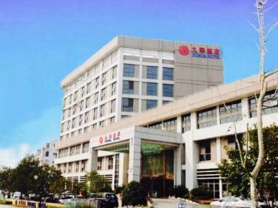

CORRESPONDANCE
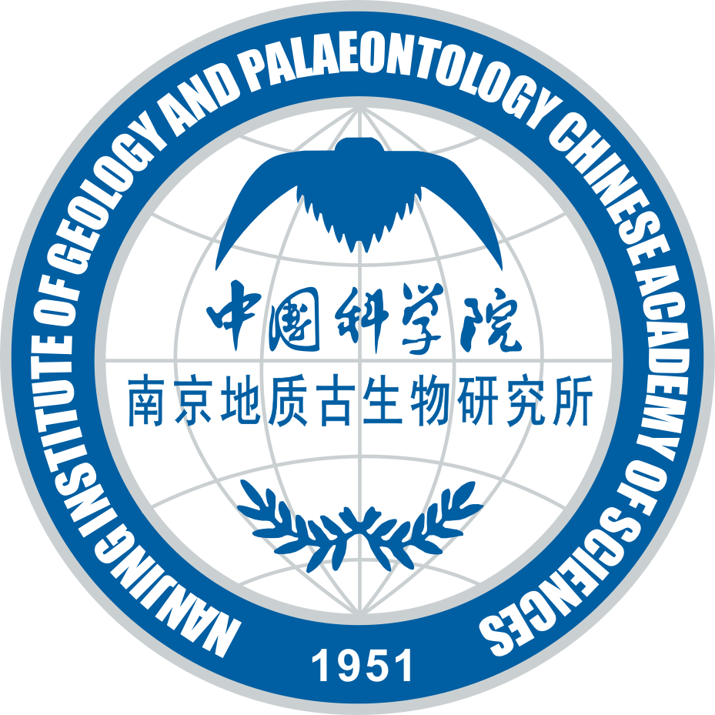
Office of Science & Technology
Nanjing Institute of Geology & Palaeontology
Chinese Academy of Sciences
39 East Beijing Road, Nanjing 210008
China
Email: kjc@nigpas.ac.cn
Tel：025-83282106, 83282198

古生物、精时地层及化石能源国际研讨会
International Conference on Palaeobiology, High Resolution Stratigraphy and Fossil Energy
November 18-19, 2021, Nanjing, China

Registration Form

Family name (last name): First name(s):
Title or position: Nationality:
Male ( ) Female ( )
Institution:
Address:
Periods of stay in China
Passport number and valid dates:
E-mail:
Phone: Fax:

● I plan to register as (use √ to indicate your choice):
Formal participant ( ); Student ( )
● I plan to give:
( ) Oral presentation entitled:

( ) Poster presentation entitled:

Other suggestions and comments:

Date:

Signature:

Please send this form by email before May 31, 2021 to:
Office of Science & Technology
Nanjing Institute of Geology and Palaeontology, CAS
39 East Beijing Road, Nanjing 210008, CHINA
e-mail: kjc@nigpas.ac.cn

